5.3 UML Diagrams
UML DIAGRAMS:
The Unified Modeling Language (UML) is a standard language for specifying, visualizing, constructing, and documenting the artifacts of software systems, as well as for business modeling and other non-software systems. The UML represents a collection of best engineering practices that have proven successful in the modeling of large and complex systems. The UML is a very important part of developing objects oriented software and the software development process. The UML uses mostly graphical notations to express the design of software projects. Using the UML helps project teams communicate, explore potential designs, and validate the architectural design of the software.
Types of UML DIAGRAMS
Each UML diagram is designed to let developers and customers view a software system from a different perspective and in varying degrees of abstraction. UML diagrams commonly created in visual modeling tools include
Use Case Diagram displays the relationship among actors and use cases
Class Diagram models class structure and contents using design elements such as classes, packages and objects. It also displays relationships such as containment, inheritance, associations and others.
Interaction Diagrams
- Sequence Diagram displays the time sequence of the objects participating in the interaction. This consists of the vertical dimension (time) and horizontal dimension (different objects)
- Collaboration Diagram displays an interaction organized around the objects and their links to one another. Numbers are used to show the sequence of messages.
State Diagram displays the sequences of states that an object of an interaction goes through during its life in response to received stimuli, together with its responses and actions.
Activity Diagram displays a special state diagram where most of the states are action states and most of the transitions are triggered by completion of the actions in the source states. This diagram focuses on flows driven by internal processing.
Physical Diagrams
- Component Diagram displays the high level packaged structure of the code itself. Dependencies among components are shown, including source code components, binary code components, and executable components. Some components exist at compile time, at link time, at run times well as at more than one time.1
- Deployment Diagram displays the configuration of run-time processing elements and the software components, processes, and objects that live on them. Software component instances represent run-time manifestations of code
Use Case Diagram:
A use case diagram in the Unified Modeling Language (UML) is a type of behavioral diagram defined by and created from a Use-case analysis. Its purpose is to present a graphical overview of the functionality provided by a system in terms of actors, their goals , and any dependencies between those use cases.

Actor
You can picture an actor as a user of the IT system, for example Mr. Steel or Mrs. Smith from check-in. Because individual persons are irrelevant for the model, they are abstracted. So the actors are called “check-in employee” or “passenger”:
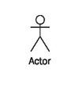
Actors represent roles that users take on when they use the IT system, e.g., the role of a check-in employee. One person can act in more than one role toward the IT system. It is important for the IT system in which role a person is acting. Therefore, it is necessary to log on to many IT systems in a certain role, for instance, as a normal user or as an administrator. In each case access to the appropriate functionalities (use cases) is granted.
Actors themselves are not part of the IT system. However, as employees they can be part of the business system (see Figure 4.5).

Use Case
Use cases describe the interactions that take place between actors and IT systems during the execution of business processes:
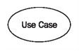
A use case represents a part of the functionality of the IT system and enables the user (modeled as an actor) to access this functionality.
Anything that users would like to do with the IT system has to be made available as a use case (or part of a use case). Functionalities that exist in the IT system, but that are not accessed by means of use cases, are not available to users.
Even though the idea behind use cases is to describe interactions, flows of batch processing, which generally do not include interactions, can also be described as use cases. The actor of such a batch use case is then the one who initiates batch processing. For instance, generating check-in statistics would be a batch use case.
Relationships:

Association
An association is a connection between an actor and a use case. An association indicates that an actor can carry out a use case. Several actors at one use case mean that each actor can carry out the use case on his or her own and not that the actors carry out the use case together:

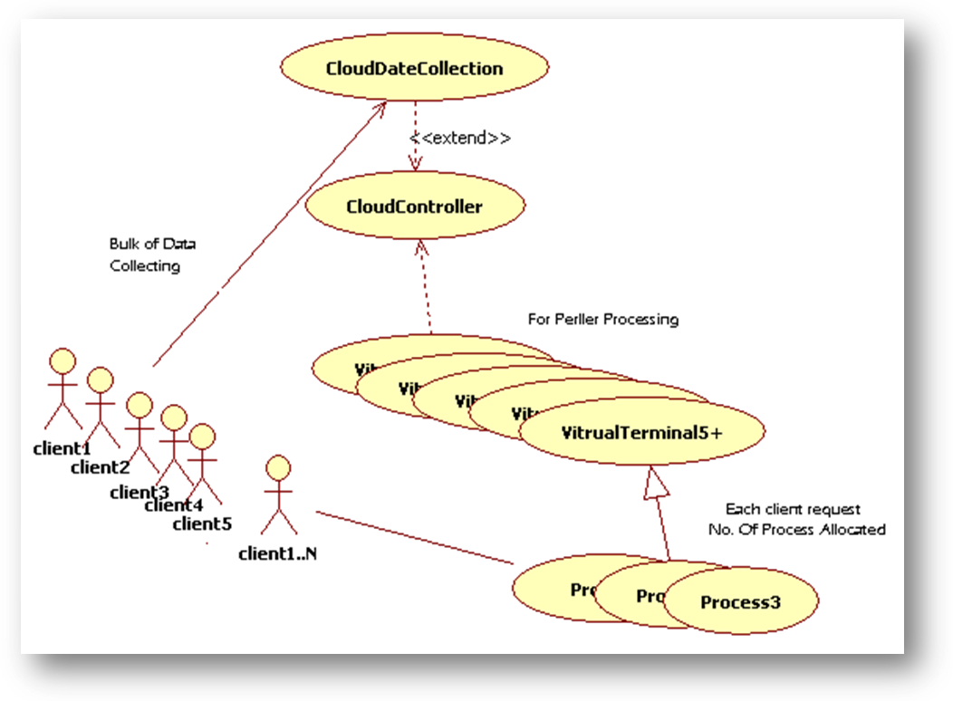

Sequence Diagram:
Séquence diagrammes bélong to a group of UML diagrams called Interaction Diagrammes. Sequence diagrams describe how objects interact over the course of time through an exchange of messages. A single sequence diagram often represents the flow of events for a single use case.
Instance: An instance of a class shows a sample configuration of an object. On the sequence diagram, each instance has a lifeline box underneath it showing it's existence over a period of time.
Actor: An actor is anything outside the system that interacts with the system. It could be a user or another system.
Message: The message indicates communication between objects. The order of messages from top to bottom on your diagram should be the order in which the messages occur.
1.Sequence digram:
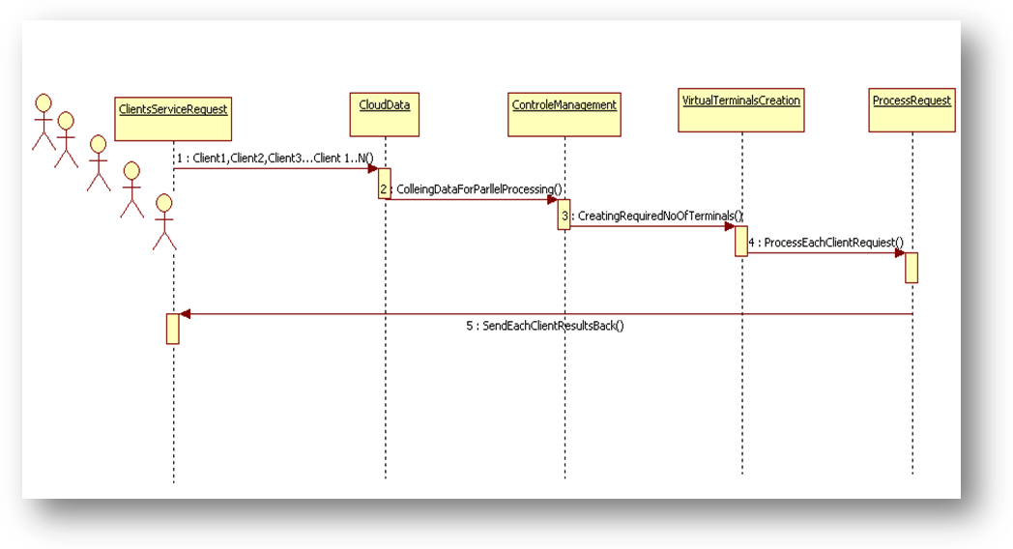

Collaboration Diagram:
Collaboration diagrams belong to a group of UML diagrams called Interaction Diagrams . Collaboration diagrams, like Sequence Diagrams, show how objects interact over the course of time. However, instead of showing the sequence of events by the layout on the diagram, collaboration diagrams show the sequence by numbering the messages on the diagram. This makes it easier to show how the objects are linked together, but harder to see the sequence at a glance.
Instance: An instance of a class shows a sample configuration of an object. On the sequence diagram, Eich instance has a life line box underneath it showing itsa existence over a period of
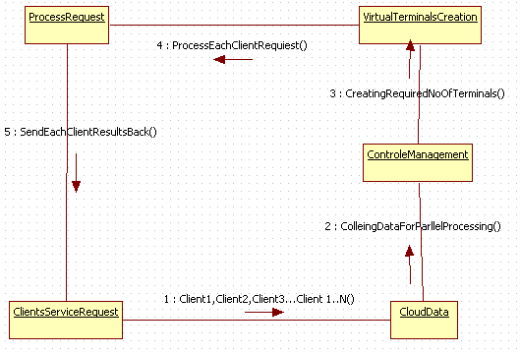

Class Diagram:
Class diagrams are widely used to describe the types of objects in a system and their relationships. Class diagrams model class structure and contents using design elements such as classes, packages and objects. Class diagrams describe three different perspectives when designing a system, conceptual, specification, and implementation. These perspectives become evident as the diagram is created and help solidify the design.
This Diagram Show the relationship between tables
There are Four Table in this Diagram

Class diagram:

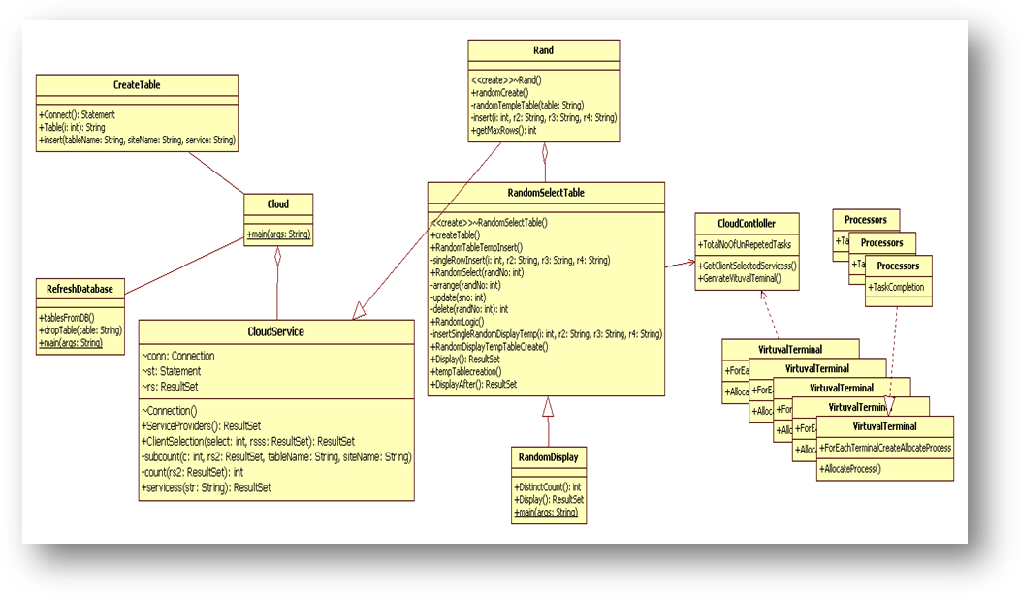
STATE CHART DIAGRAM
Introduction
State diagrams are used to describe the behavior of a system. State diagrams describe all of the possible states of an object as events occur. Each diagram usually represents objects of a single class and track the different states of its objects through the system.

When to Use: State Diagrams
Use state diagrams to demonstrate the behavior of an object through many use cases of the system. Only use state diagrams for classes where it is necessary to understand the behavior of the object through the entire system. Not all classes will require a state diagram and state diagrams are not useful for describing the collaboration of all objects in a use case. State diagrams are other combined with other diagrams such as interaction diagrams and activity diagrams. ¹

How to Draw: State Diagrams State diagrams have very few elements. The basic elements are rounded boxes representing the state of the object and arrows indicting the transition to the next state. The activity section of the state symbol depicts what activities the object will be doing while it is in that state.
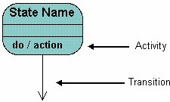

STATE CHART DIAGRAM
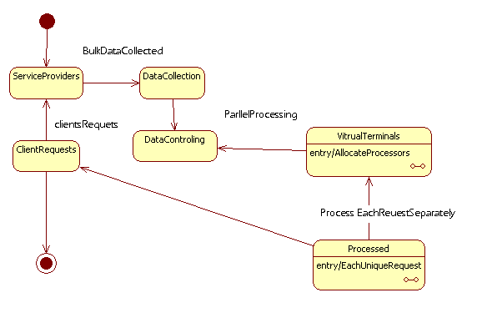

ACTIVITY DIAGRAM
Introduction
Activity diagrams describe the workflow behavior of a system. Activity diagrams are similar to state diagrams because activities are the state of doing something. The diagrams describe the state of activities by showing the sequence of activities performed. Activity diagrams can show activities that are conditional or parallel.
Activity diagrams describe the workflow behavior of a system. Activity diagrams are similar to state diagrams because activities are the state of doing something. The diagrams describe the state of activities by showing the sequence of activities performed. Activity diagrams can show activities that are conditional or parallel.
Activity diagrams should be used in conjunction with other modeling techniques such as interaction diagrams and state diagrams. The main reason to use activity diagrams is to model the workflow behind the system being designed. Activity Diagrams are also useful for: analyzing a use case by describing what actions need to take place and when they should occur; describing a complicated sequential algorithm; and modeling applications with parallel processes.
Activity diagrams: in this project there are six Action States
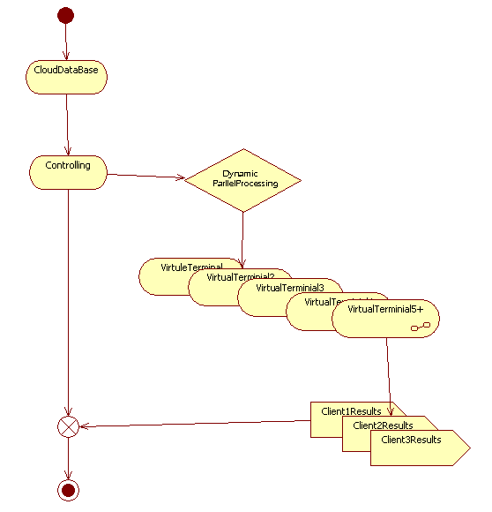

Activity diagrams

Deployment diagram:

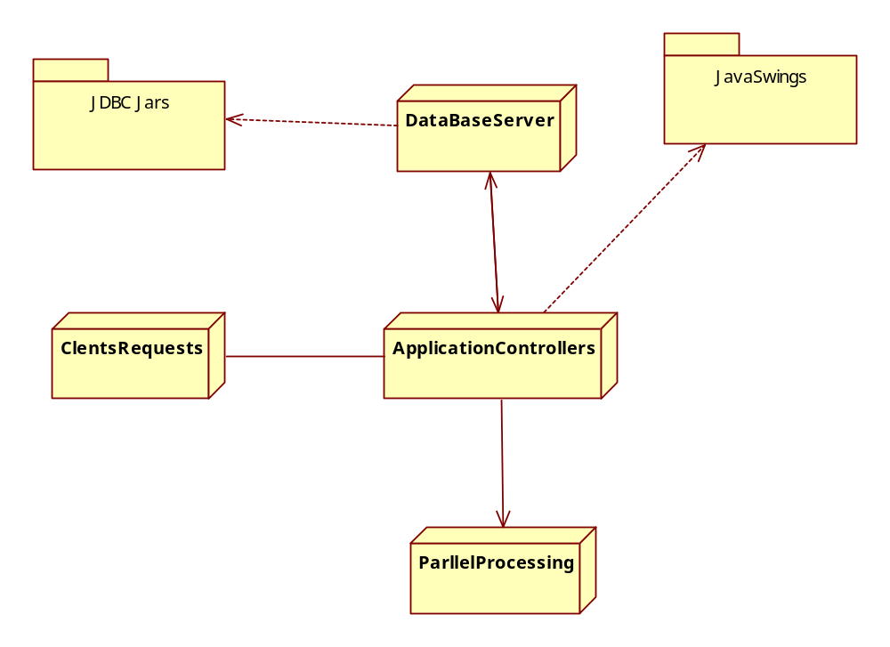

Component diagram:
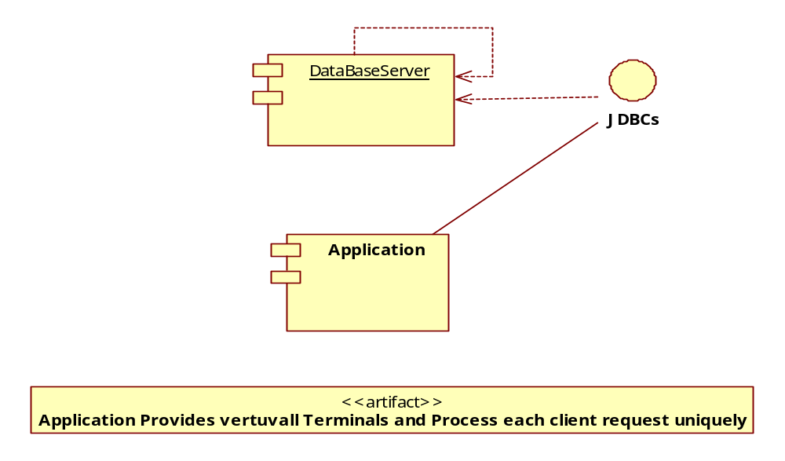

EF Diagram:
